Golf Handicap Companion

Initial setup
It is the case that there is an amount of work needed to setup the golf handicap companion app. This document guides you through the process step by step explaining some of the areas to be careful of.

This app is designed to be a companion to your official handicap record. This means that the correct data lies in the official golf record and the score differentials within the app must be the same. In the case of Scotland the best place to find your handicap record is on the Scottish Golf app. This presents the following screen.

The overall information is shown including the low h/cap index. For each round, the course, its slope and rating, the adjusted gross and score differential, and any adjustments are shown.

The key thing here, or for whichever record you use, is that the app data matches the order of scores and the score differential is the same.

Scores in the app are sorted by date/time order. The score differential if it is not the same as the calculated value can be overridden in the app so that it is the same.

Initial handicap differential calculations, prior to the introduction of WHS, were made using the CSS of the round rather than the course rating. This is one of the reasons why the differential may be different from the calculation.

When the app starts for the first time the following setup screen is shown.
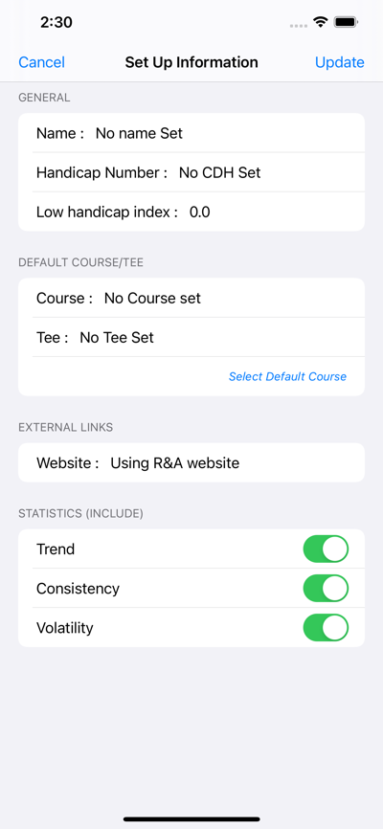
At this stage the player’s name can be entered and a default course can be created. This screen can be accessed at anytime from the gear symbol on the home screen of the app.

The app has a link to the R&A app to allow the lookup of courses worldwide to get their slope and rating. If a different website is preferred then this can be entered. When entering a website the http:// needs to be included.

The CDH and low handicap index can be entered here but these are not used within the app.

The three measures that are shown on the home screen can be switched on and off from this setup screen. The three measures are:

- HI trend – this will show a short and long term trend which equates to the difference between the current HI and 5 scores back and the current HI and 20 scores back respectively. The short term trend will not appear until 7 scores have been entered and the long term will not appear until 22 scores have been entered.
- Consistency or last 8 – this is the average of the last 8 scores on the record. This is intended to show how close you are playing to your handicap index.
- Volatility or 3 bad – this is the best 8 from the last 17 scores. This shows what will happen to your handicap if you have 3 bad scores in a row. A bad score is defined as being greater than the highest differential in your current best 8 scores.

The enter course screen is :

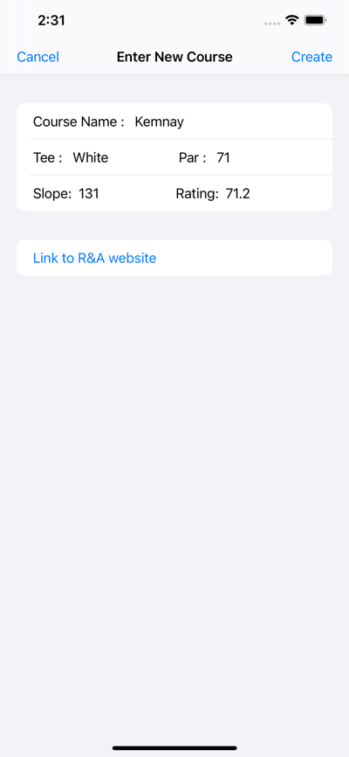
Here you enter the course name, the tee, the par, the slope and the rating. A different entry is needed for each tee that is used at a course.

This is where the link is to the R&A website where the pars, slopes and ratings can be found.

The par is only needed if the course handicap calculation is going to include the rating – par number. This is not used in Great Britain & Ireland.

Each course used by the app needs to be entered in this fashion. The course setup as the default app will be in use when a score is to be entered or next round information to be checked.

Once the setup data has been created you are asked to enter scores. The main home screen is not shown until 3 scores have been entered. The screen used to enter scores is:

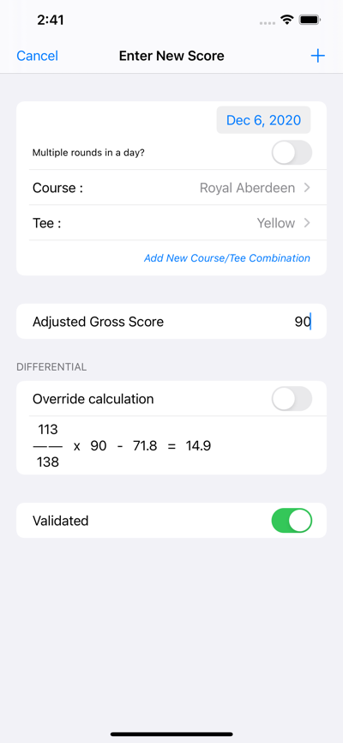
To enter a score you enter the date, select the course and enter the adjusted gross score of the round. The calculation is then shown. If the score differential is different between the official handicap record and the calculation then toggle the override calculation switch and manually enter the score differential from the official handicap record.

As was stated previously, this will be the case with records created based on the CSS which were used in the initial creation of a handicap.

When taking data directly from the official handicap record the validated flag should be selected.

Any number of scores can be entered if they exist but a minimum of 3 scores is needed to see a HI. The app calculates the HI as stated in the WHS when less than 20 scores are input. When 20 scores are input then the best 8 are used to calculate the HI.

If a mistake is made with the entry of a score it can be deleted by swiping left of the scores list of the score view screen.

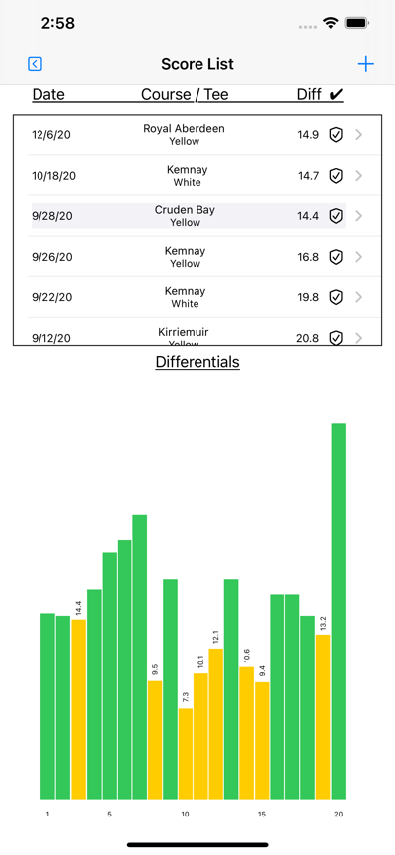
This screen shows the 20 scores (or less) involved in the handicap calculation. The yellow bars are the ones that count towards the handicap calculation.

The tick inside the shield means that the validated flag has been set.

Scores can be added from this screen by pressing the “+” and scores can be edited by selecting the score to edit. The location or date of a score cannot be edited if these are wrong then the score must be deleted and re-entered.

Scores are sorted by date and time. On the score entry form it asks if multiple rounds were played in a day. If yes then the option to set both the day and time is presented. The key is that the scores should be in the same order as in the official handicap record.

It does take some time to setup the 20 scores to begin using the app properly but once the data is in it does not need to be re-entered. My estimate is between 30 mins and 1 hour. When all records have been input then the home screen will look like.

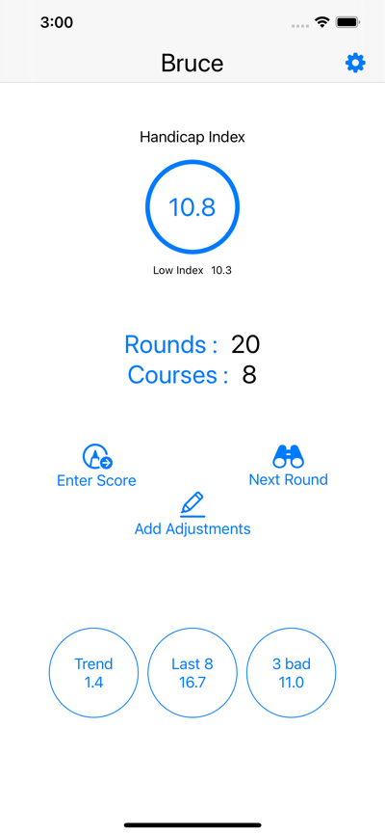
Pressing on the HI takes you to the score view screen. Pressing on the rounds shows all rounds that are entered and gives access to simple statistics. Courses gives access to all courses entered and allows the entry of new courses.

The adjustments button will add an adjustment to the last 20 scores in the app. The two areas where adjustments can happen is from the handicap administrator or if an exceptional score is scored. For example if a score is posted 7 shots better than the current handicap index then the handicap index is reduced by 1. This is done by entering an adjustment on all 20 scores.

The three measures can be seen at the bottom of the screen and these can be switched on and off in the setup screen available from the gear symbol in the top right corner.

Normal Use
Once the initial data has been setup then use of the app is easy. The requirement is that the data agrees with the data held on the official handicap record. The extra information that the app is looking to provide includes:

- Demonstration of the calculations used in practice
- Visual view of how the handicap is made up
- Calculation of course handicap for next round
- Identifies the differential that will be lost
- Gives the score required to see an improvement in the HI
- Shows the effect that a bad score will have on the HI

When a round is played then the score should be entered using the following screen

The date course and adjusted gross score should be entered. Ideally this is entered on the day of the round.

The validated flag should be left unchecked as there may be a playing conditions adjustment that will be unknown until the following day.

The day after the official handicap record should be reviewed to see if there were any changes.

The record should then be updated with any changes and the validated flag set.

The update record screen is shown in the next picture.

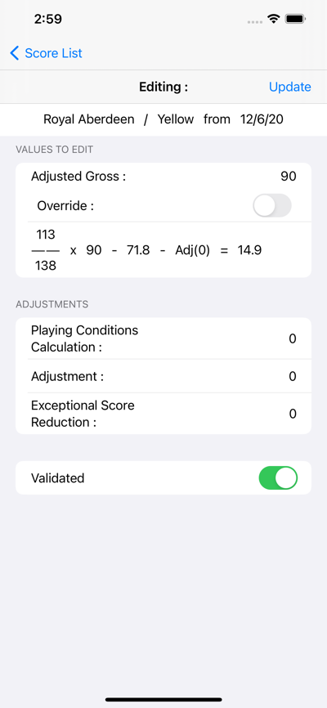
The update screen allows the adjusted gross to be updated, the score to be overridden and adjustments to be added.

The key is that the scoring record in the app needs to have the same differential as in the official scoring record. There is a lot of freedom to allow the two records to be identical because if they are not then the results in the app will not be correct.

Next Round
The next round screen gives information on what effect is possible in the next round played.

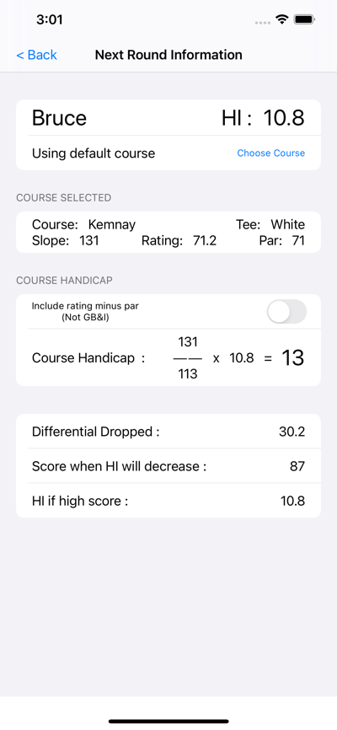
This screen shows the HI for the player, the course handicap for the next course to be played. You can choose whether to include the “rating – par” if required.

The screen also states what differential will be dropped from the 20, what adjusted gross score will improve the handicap index and what the HI will be if the score is not one of the best 8 scores.

Configuring Widget
The app has an associated widget that allows easy access to the app and shows the handicap index on the home screen.

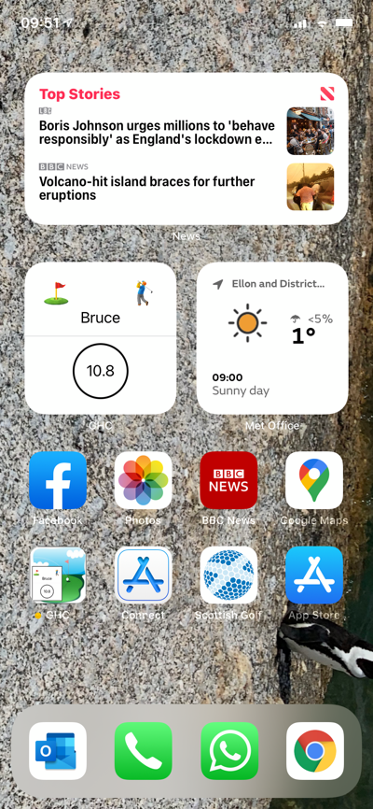
To add the widget to a home screen,

- Press on a clear space on the home screen
- Until the icons and widgets wiggle.
- Select the “+” at the top left corner of the screen
- Scroll down until see widget “GHC”
- Select “Add Widget”

The widget will update whenever the HI changes in the app.

Pressing on the widget will open the app.

